**Biosafety and biosecurity on-site training for laboratory staff with focus on risk group 3 pathogens**

**21-30th of November 2022, Malawi**

The Norwegian Institute of Public Health (NIPH) has organized a training course in biosafety and biosecurity in cooperation withthe Public Health Institute of Malawi (PHIM), the Norwegian Veterinary Institute (NVI) and Central Veterinary Laboratories (CVL), within a One Health perspective.

The training was organized under the BIS (Building stronger Institutions and Systems)- programme, a long-term twinning project between PHIM and NIPH. Biosafety is one of the four main areas of collaboration demanded by PHIM in the BIS- Malawi project.

The training was performed at two sites. First at PHIM in Lilongwe with a two-and-a-half-day long course with 24 participants from PHIM and CVL. Next, we had a one-day course in Blantyre at the Queen Elisabeth Central Hospital with 22 participants from laboratories at the hospital, from DREAM lab and from the Regional Veterinary Laboratory.

The 2 ½ day training in Lilongwe consisted of lectures, interactive sessions, practical demonstration and group-work on biosafety and biosecurity with special attention to laboratories with heightened control measures (BSL3). Biorisk assessment was in focus, and participants were divided in groups and trained on practical risk assessment with three different scenarios, facilitated by the course organizers. All groups presented their results in a joint session. Deputy director of PHIM, Mr. Bitilinyu-Bangoh formally opened the workshop and the Director of PHIM, Dr. Ben Chilima, formally closed the training. The main facilitator at PHIM was the national coordinator for biosafety and biosecurity, Mr. Mabvuto Chiwaula.

The one-day training in Blantyre consisted of lectures, interactive sessions, practical demonstration on biosafety and biosecurity with special attention to laboratories with heightened control measures (BSL3). Lectures on biorisk assessment was also included, but due to time restrictions, group-work was omitted from this training. Deputy director of PHIM, Mr. Bitilinyu-Bangoh formally opened the workshop. The main facilitator at Queen Elisabeth was Ms. Chifundo Banda, from PHIM.

Participants were mainly senior laboratory staff from both public health and veterinary sectors. Dissemination strategy for the course should be planned to approach colleagues from both central and regional level for both sectors.

All participants evaluated the course. The overall opinion from participants at the Lilongwe training was that the course was relevant and interesting, especially the risk assessment training. Also, the interactive format of the course was appreciated. Some gave feedback that they would have liked more details and more time for the course. In response to this, we agreed to establish a Whats-app group to discuss biosafety and biosecurity questions between the sectors and the two countries, and that we should plan for a digital meeting for all the participants in three months’ time.

The participants from Blantyre also agreed that the course was relevant end interesting, but many gave feedback that the course should have been longer, at least two days. The course organisers from Norway agree on this feedback. Also here, the risk assessment lecture and discussions were appreciated. Some would have liked to have practical training in the laboratory, especially on how to work in the biosafety cabinet. This is something that might be facilitated by PHIM expert.

All participants received a certificate to confirm that they had finished the training

In addition, the Norwegian expert team visited laboratories at PHIM and CVL in Lilongwe, and at Queen Elisabeth, CVL and Dream in Blantyre.

## Lilongwe:

**Course:**

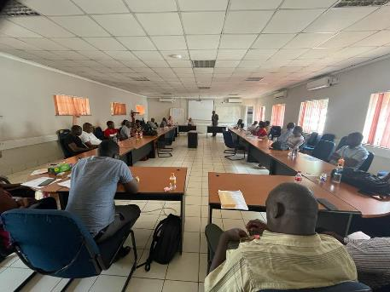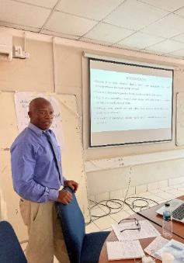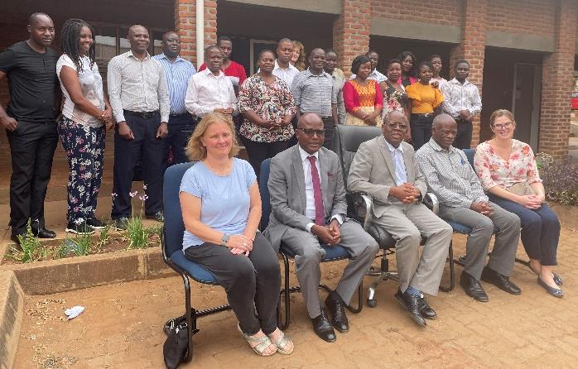

**Group work and presentations:**

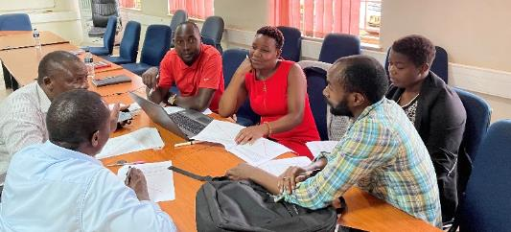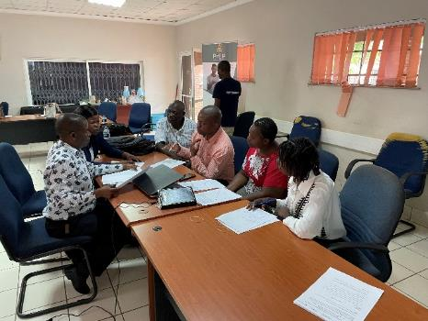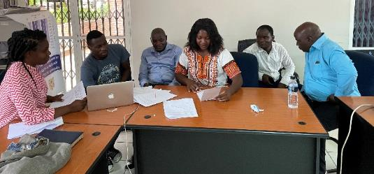

**Certificate ceremony:**

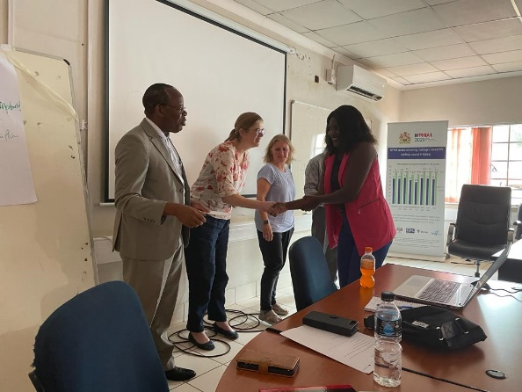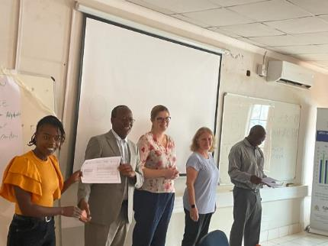

**Laboratory visit at PHIM and CVL**

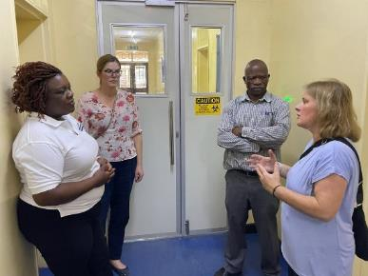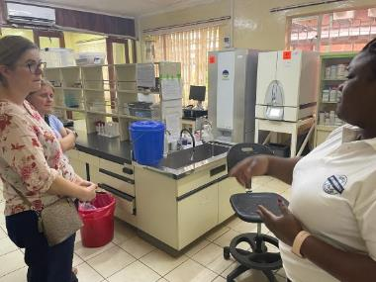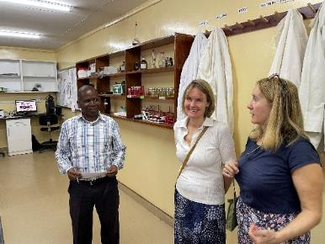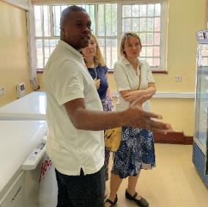

.

## Blantyre:

**Course in Blantyre**:

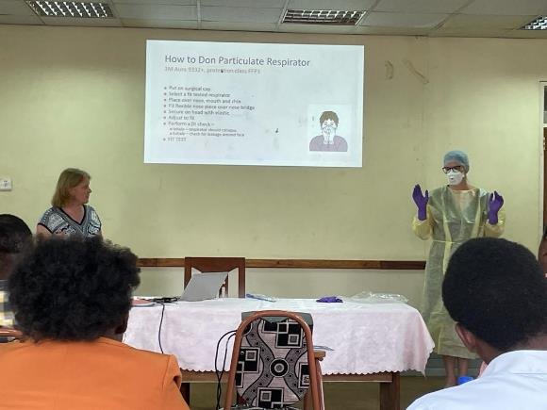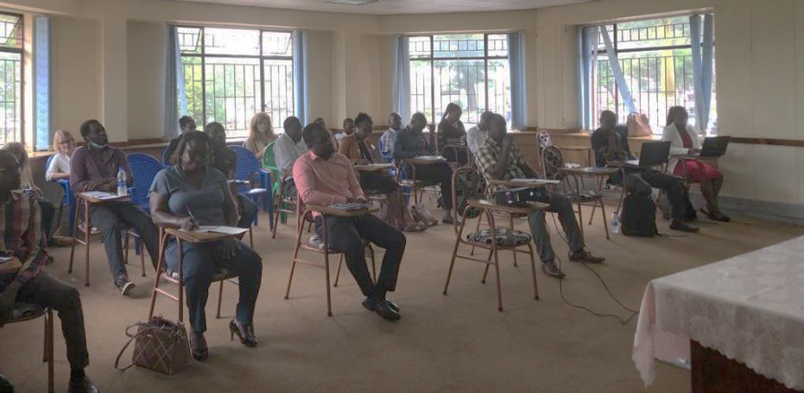

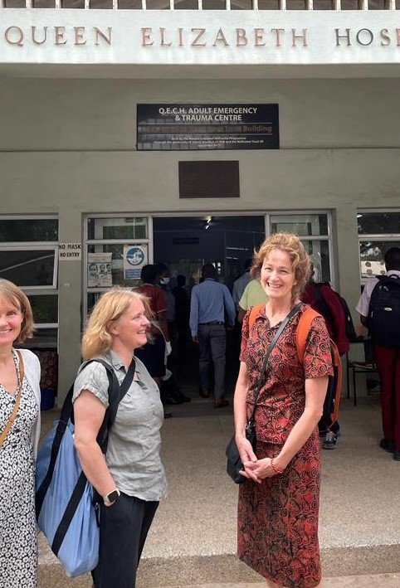

**Laboratory visits, Queen Elisabeth Central Hospital and Dream Laboratory**

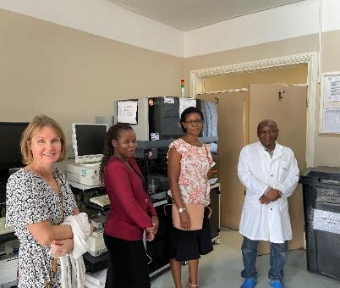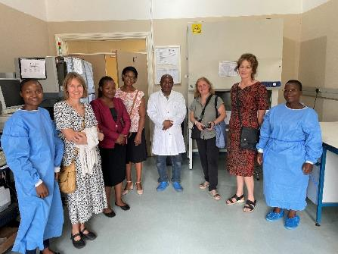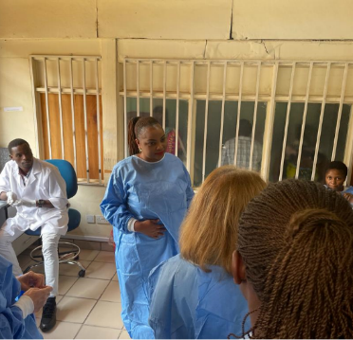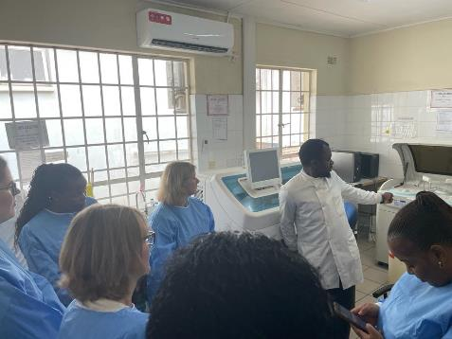

# Annex 1. Agenda for Lilongwe and Blantyre

**By:** Siri Feruglio MD, PhD, Tone Bjordal Johansen, DVM, PhD and Trude Arnesen, MD, PhD, Norwegian Institute of Public Health (NIPH, BIS-project), with support from Siv Klevar, DVM, PhD, the Norwegian Veterinary Institute (NVI) and Ingrid Olsen, MD, PhD, Oslo University Hospital (Norwegian One Health consortium)

**Target audience:** Senior laboratory staff with regular work in BSL3-laboratories (train-the -trainer)

Lilongwe

**Day 1 (Tuesday 22. Nov)**

**Site: PHIM**

**Agenda:**

09:00 – 16:00

* Welcoming remarks (Dr. Ben Chilima, Director of PHIM, 15 min)
* Presentation of laboratories at PHIM (Dr. Joseph Bitilinyu-Bangoh, PHIM, 15 min)
* Presentation of other participating laboratories (Joseph Nkhoma, CVL, 15 min)
* Presentation of NIPH and introduction to program (Siri Feruglio, 15 min)
* Veterinary preparedness diagnostics in Norway (Siv Klevar, NVI, 15 min)
* Principles of Biosafety and Biosecurity with focus on BSL3-laboratories (Tone Johansen, 30 min)
* **Short break** (10 min)
* Biosafety and Biosecurity contd. (BSL3 facility design, laboratory equipment, biohazardous waste management) (Tone Johansen, 45 min)
* Biosafety and Biosecurity in Malawi (Dr. Mabvuto Chiwaula, PHIM, 15 min)
* **Lunch (60 min)**
* Biosafety/ biosecurity and laboratory diagnostics of risk group 3 pathogens (One Health)  
  + Rabies (Joseph Nkhoma (CVL) and Siv Klevar (NVI), Dr. Mabvuto Chiwaula (PHIM), 45 min)
  + Anthrax (Joseph Nkhoma (CVL), to be decided (PHIM) and Tone Johansen (NIPH), 45 min)
* Plenum discussion and trouble shooting

**Day 2, Wednesday 23. Nov**

**Site: PHIM**

**Agenda:**

09:00 – 16:00

* Practical work in the BSL 3 lab. (Tone Johansen and Siri Feruglio, 45 min)  
  *Reception of a sample, registration, how to work in the biosafety cabinet, buddysystem, use of disinfectant, waste management, Inactivation/DNA isolation*

*use of* *PPE, donning and doffing*

* Presentation and practical demonstration of principles of donning and doffing and use of PPE (Tone Johansen and Siri Feruglio, 30 min)
* Group discussion on experiences and practices (All, 30 min)
* **Short break (10 min)**

**Incident and accident workshop**

* Laboratory accidents, risk assessment planning and management (Tone Johansen, 60 min)
* **Lunch (60 min)**
* Table-top exercise (Spill accident, technical breakdown) (All, group work, 60 min)
* Each group presents results from discussion (All, 45 min)

**Day 3, Thursday 24. Nov**

**Site: PHIM  
Agenda:**

9.00-11.00

* Shipment of dangerous goods (updated short practical demonstration of principles) (Tone Johansen, 20 min)
* Bio preparedness laboratory networks/ projects and EQAEs (Tone Johansen, 15 min)
* Troubleshooting/ joint discussion (All, 30 min)
* Dissemination strategy (All, 30 min)
* Evaluation (All, 15 min)
* Lunch and end of training

**__________________________________________________________________________**

**Thursday 24. Nov, after lunch**Norwegian delegation visits laboratories at PHIM

**Friday 25.11 (1/2 day, 09.00-11.00)**

Discussion between Norwegian delegation and health stakeholders

**Topics:**

* Discuss Biosafety and Biosecurity guidelines currently in development in Malawi in relation to 2019 JEE
* Optional: Meeting with responsible persons for planning of BSL-3 laboratory
* Round up discussion

**End of program in Lilongwe**

Blantyre

**Day 1 (Monday 28. Nov)**

Norwegian team visits laboratories (Queen Elisabeth Central Hospital and others)

**Day 2 (Tuesday 29. Nov)**

**Site: Queen Elisabeth Central Hospital**

**Agenda:**

09:00 – 16:00

* Welcome and introduction from Queen Elisabeth Central Hospital
* Presentation of participants and laboratories
* Presentation and introduction to program (Siri Feruglio, NIPH)
* Biosafety/ biosecurity and laboratory diagnostics of risk group 3 pathogens (One Health) - rabies (Joseph Nkhoma, CVL and Bessie Phiri, PHIM)
* Principles of Biosafety and Biosecurity with focus on BSL3-laboratories (Tone Johansen, NIPH)
* **Short break**
* Biosafety and Biosecurity part II (BSL3 facility design, laboratory equipment, biohazardous waste management) (Tone Johansen, 45 min)
* Practical work in the BSL 3 lab. (Tone Johansen and Siri Feruglio)
* **Lunch**
* Presentation and practical demonstration of principles of donning and doffing and use of PPE (Tone Johansen and Siri Feruglio)
* Laboratory accidents and risk assessment (Tone Johansen)
* Evaluation, plenum discussion and certificates