This case study is aimed to be applied jointly by employees of the municipal public health service and employers of foreign temporary workers. Employees of other municipal institutions, such as social services, or NGOs, could be included if appropriate. The estimated duration of the case study is 3,5 hours.

Learning objectives
After case study completion, participants should be able to:
- Define key components and actors of an effective outbreak response.
- Determine responsibilities of the municipality and of the employer in outbreak response.
- Recommend a plan for recording of foreign temporary workers for public health purposes.
- Identify communication channels and feedback loops between different key actors.
- Determine potential barriers to compliance with control measures.
- Describe cases in terms of time, place and person.
- Calculate attack rates in an outbreak setting.
- Integrate ‘lessons learned’ from an outbreak into the municipal preparedness plan.

Case study developed by Elburg van Boetzelaer, Annlaug Selstø, Elina Seppälä, Kjetil Berg Veire, Anette Ester and Pawel Stefanoff.

PART I. ALERT
(estimated time: 45 minutes)

On 19 August 2020 the municipal doctor in municipality X is informed about three confirmed COVID-19 cases among employees of an industrial plant. The municipal doctor is following up on the situation and finds the following information:
One of the cases (index case 1) had tested positive at the airport when entering Norway. Before he got the results, he had gone to work at the industrial plant, resulting in six close contacts who had potentially been exposed.
The second case (index case 2) was also employed at the plant but lived permanently in the village. He did not have any contact with the other positive cases. He had been to work and was active in the local community, participating in meetings at his children's school and kindergarten, and socialising with other people. Following the positive test result of index case 2, the school and kindergarten had been closed while the municipality doctor worked on getting an overview over the situation. Contact tracing had identified 41 close contacts of index case 2 who needed to go into quarantine.
The third case (index case 3) initially tested negative for COVID-19, but a second test turned out positive. At that time, the employer retested all coming from abroad 3 days after crossing the border.

Questions:
- Should the municipal doctor be concerned about this situation? Justify your answer.

- Could the situation be of interest for the community and the media, and how would you prepare for this?

The municipal doctor considered the following facts.
- Pathogen: SARS-CoV-2 virus which causes COVID-19 disease. It is a novel coronavirus that began to circulate among humans in late 2019. The fact that SARS-CoV-2 is a novel pathogen means that the virus has been able to spread easily in fully susceptible populations.
- Transmission: The virus spreads from person to person via small respiratory droplets which are spread when an infected person sneezes, coughs or interacts in close proximity with others. These droplets can be inhaled or end up in the respiratory tract through the hands if a person touches surfaces contaminated with the virus, or by handshake with an infected person.
- Infectiousness: It has been estimated that one contagious person can infect an average of 2-3 other people if no control measures are in place. Some people, especially children and young adults, can be infected without any symptoms. The infectious period may begin up to 2 days before symptom onset, however, people are most infectious were the first symptoms develop. The infectious period is estimated to last for 8-10 days in moderate cases requiring hospitalization, and up to an average of 2 weeks in severe cases. The time between infection and symptom onset is usually 5-6 days but can vary from 0-14 days. For some people, some symptoms may linger or recur for weeks or months following initial recovery. This can also happen in people with mild disease. People are not infectious to others during this time.
- The rather long infectious period and the fact that an infected person can transmit the disease to others before symptom onset means that the disease can spread rapidly from one single infected person if control measures are not implemented early on.
- Severity: Most people (70-80%) experience a mild respiratory infection, but some require hospitalization, even intensive care. A small proportion of cases die.
With the consideration of the above, since July 2020, the Norwegian Directorate of Health has recommended municipalities to follow the “TISK” strategy. The strategy consists of testing (“T”) all persons suspected to be infected with SARS-CoV-2 , isolating (“I”) confirmed cases , tracing (“S”) close contacts of confirmed cases and placing them in quarantine (“K”).
Note: In an epidemiological investigation of the outbreak, the first step is to “confirm the outbreak”, i.e. find evidence that the disease risk in any given time and place, exceeds the expected (acceptable) level. This decision, which is equivalent to setting an alarm, also means that starting from now, resources will be prioritized to contain the outbreak.
The municipality is concerned about the situation and declares an outbreak based on the national definition of at least two linked cases. Until the alert on 19 August, few COVID-19 cases had been reported in the municipality. The municipal doctor is concerned that COVID-19 disease awareness is low among residents and foreign temporary workers. Therefore, the municipal director initiates mass screening of municipality inhabitants for the early detection of further transmission at this point of the outbreak. Independently, the employer starts mass-screening for COVID-19 of foreign workers at the industrial plant.
The municipal leadership is aware that even few cases in a small municipality can attract media attention. Closing the school can also create anxiety, even if it is for a short time period. They observed how communication can be challenging when outbreaks were occurring previously in neighbouring municipalities. One way to prepare for increased media attention would be to identify communication channels and involve stakeholders in collaboration and communication.

The best way to prepare for a crisis is to develop a communication plan:
- To specify where and how often to publish updated information about the situation (‘situation reports’),
- To prepare for the most frequently asked questions both from the inhabitants and the media,
- To identify one or more spokespersons to whom all questions could be directed.
The crisis communication should be timely and transparent. The local community and the media must receive all necessary information about the epidemiological situation.
During an outbreak, the spokesperson(s) should be kept in the loop for all information exchanges. Since this is a small municipality having a large group of foreign workers, the municipality should collaborate with the employer on all communications with the media.

Question:
- What additional information would you like to receive about the industrial plant premises and its employees to guide your outbreak response?

Approximately 30 % of the 455 plant employees are permanent residents of the village and neighbouring villages. The remaining 70 % employees are temporary foreign workers. Most live in the barracks on the premises, while some live in rented houses in neighbouring villages.
The industrial plant premises are located 4 kilometres away from inhabited areas of the municipality. Barracks are located at walking distance from the plant (see Figure 1). Each barrack has 40-60 single rooms (20 m2), most of them with a private (en-suite) bathroom. Some barracks have access to a common kitchen space. All barracks have a common space for social gatherings. All workers have access to the canteen organised by the employer.
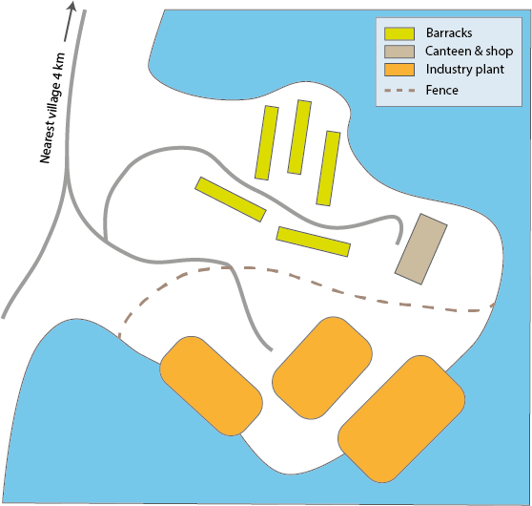
Figure 1. Map of the premises of the industrial plant

The foreign temporary workers are working on 6-8 weeks rotation shifts. After each shift, the workers return to their home countries and are replaced by a new group of workers.
Most of the work at the plant is conducted in confined indoor spaces which are poorly ventilated. Different teams specialise in welding, plumbing or electrical installations. The employer is now trying to implement measures for social distancing at the plant.

Question:
- What challenges are there to contain Covid-19 outbreak in this type of workplace?

The municipal doctor contacts the Human Resources (HR) Director of the plant. The employees are frustrated because they don’t know how long they must stay in quarantine. The HR Director says that information on recommended control measures, testing rules, quarantine and isolation has been communicated to all employees both directly and through subcontractors. She specifies that some employees have not adhered to the quarantined rules. She denotes that there are communication problems with the foreign temporary workers, since many do not speak either of the two languages used for disseminating messages (Norwegian and English). Moreover, the HR Director says she can only send information to staff on the plant direct payroll. Most of the employees are hired through subcontractors, and subcontractors of subcontractors. The dissemination of information to employees of the industrial plant must go through these subcontractors. Therefore, she is not sure if all the advice and recommendations have reached all employees through the above-mentioned subcontractors. All of the above leads to challenges in communication as well as overview over the list of all employees.
On 21 August, close contacts of index case 2 (work contacts and the 17-year old daughter of index case 2) test positive for COVID-19. Following the positive test results, 16 school children and a group of kindergarten pupils are placed in quarantine. By 22 August there are 13 confirmed cases, of which only 3 among permanent residents. Two of the new cases have recently travelled from abroad and were most likely infected abroad. The three cases in the local community are family members of a plant employee. During this period, all travellers entering Norway from abroad can “test their way” out of quarantine, with two negative tests with the minimum of a three days interval. This leads to massive testing at the workplace, so that people could go to work without quarantining for 10 days.

Question:
- How would you ensure that the employees and the permanent residents are able to follow the advice and control measures?

To ensure that people who test positive for COVID-19 at the airport do not come to the workplace, the employer may consider giving employees information about sick leave, organise quarantine and isolation facilities, access to meals and social support as well as uninterrupted payment of wages.
The municipal doctor finds information about COVID-19 and current quarantine and isolation rules in languages other than Norwegian and English on the Norwegian Institute of Public Health's website www.fhi.no. They want to reach both the local population and all employees with relevant and up-to-date information.

PART II. RAPID PROGRESSION OF THE OUTBREAK
(estimated time: 45 minutes)

On 27 August the HR Director of the plant informs the municipal doctor that all 455 employees were tested between 22nd and 26th August and that an additional 55 COVID-19 cases were confirmed. This triggers questions from the media and neighbouring municipalities, putting the municipal leadership under a lot of pressure. At the same time, municipality representatives receive messages from worried inhabitants, informing about foreign workers doing shopping at the local grocery shop. This happens several times and especially workers from country A are being stigmatised.
The municipal director informs the county governor about the outbreak, and together they decide to request the assistance of the Norwegian Institute of Public Health (FHI). FHI agrees to send infection control and disease tracing experts who, together with local stakeholders, form an outbreak investigation team.

Questions:
- Who should be part of the outbreak investigation team?

- What could be the reasons that the number of cases has increased so fast?

On 28 August, the outbreak investigation team starts to operate. In an outbreak that involves a workplace, an outbreak investigation team could include an infection control specialist, contact tracing expert, epidemiologist, microbiologist and communication expert. The team should also include the municipal doctor, local authorities and a representative of the employer. The outbreak investigation team decides that their main task will be to review the existing information on the cases reported from the municipality and the industrial plant, and to clarify the roles of different actors in the outbreak response. An effective outbreak response will allow development of recommendations on how to limit further spread of this outbreak and how to prepare for future outbreaks.
The outbreak investigation team discusses the possible reasons behind the rapid increase in the number of cases. It is known that transmission can be particularly effective in crowded, confined indoor spaces, where poor ventilation can further enhance the spread of SARS-CoV-2. Furthermore, sharing transportation and facilities such as common accommodation, canteen and dressing rooms, may contribute to enhanced transmission. The team agrees that the conditions at both the plant and the barracks favour the spread of COVID-19.,
In addition to the physical conditions of the working and living environment, the employer’s and employees’ knowledge of and adherence to guidelines regarding prevention of COVID-19 outbreaks likely plays a role. The team suspects that communication regarding COVID-19, including isolation and quarantine rules and other preventive measures, may be limited. Some employees may not follow isolation and quarantine rules and other recommendations. Possible reasons for that could be lack of awareness, lack of understanding or perceiving COVID-19 as a mild disease.
The outbreak investigation team also considers the possibility of a “super spreader event”, an event where one highly infectious case transmits the disease to many others, leading possibly to uncontrolled spread of the disease. Before the COVID-19 pandemic started, super spreader events were described for the severe acute respiratory syndrome (SARS) outbreak in 2003, when epidemiologists noted that a small proportion of cases were responsible for most transmissions. This has now described for COVID-19. Super-spreader events have occurred in slaughterhouses, factories and religious gatherings.
Due to insufficient facilities for mass-quarantine and isolation at the plant, the plant management closes the plant and, in collaboration with the municipality, decides to place some of the confirmed cases and some of the employees in quarantine in designated facilities in other municipalities. These are mostly hotels adapted to isolation centres that have appropriate conditions and trained staff. While discussing containment measures, several questions are raised around the roles and responsibilities of the different actors regarding employees who are placed in quarantine in other municipalities.
Discussion points include:
- Who is responsible for the supervision and wellbeing/health of these employees?
- Who is responsible for the testing of these employees?
- Who is responsible for reporting of new confirmed cases among these employees to regional and national authorities?
Questions:
- How could the different municipalities collaborate?

- What could be the role of the county governor?
In the following days, the county governor organises a meeting with neighbouring municipalities. During this meeting the participants agree that each of the municipalities is unable to deal with such a large outbreak on their own due to limited resources. Therefore, the municipalities decide to share resources, for example health personnel speaking the languages of the plant foreign workers and assist each other in contact tracing.
During the meeting it is also agreed that the municipality where the employees of the industrial plant are temporally quarantined is responsible for the testing and assuring their safety and wellbeing. However, the municipality of residence (i.e., where the plant is located) is responsible for reporting to the regional and national authorities.
Note: the Norwegian government has developed specific reporting requirements during the COVID-19 pandemic:
- Each healthcare worker who identifies a confirmed case of COVID-19 shall notify the municipal doctor.
- The municipal doctor shall notify a COVID-19-associated death to the infection control doctor on duty at the Norwegian Institute of Public Health.
- Every laboratory and physician who identifies a confirmed COVID-19 case shall report the case to the Norwegian Surveillance System for Communicable Diseases (MSIS).
- The municipal doctor shall notify a COVID-19 outbreak to the Norwegian Institute of Public Health through the outbreak reporting system (Vesuv).

Since 2017, the municipality was working to adopt the crisis preparedness plan, which was part of the national preparedness planning process. The municipal director found out, however, that:
- The municipality is not prepared for such a sudden increase of cases of an infectious disease.
- The plan includes scenarios based on influenza, a disease with slightly different characteristics.
- There is not enough emphasis on communication challenges, especially in relation to such a large group of foreign workers.
The municipal director decides to prioritize the communication challenges first. With the help of the outbreak investigation team and other stakeholders, he starts to list all actors that needs to be kept in the feedback loops.

Question:
- It is useful to think at this stage who is responsible for which aspects of crisis communication. Connect all the actors who should be involved in communication during such a crisis with arrows. Use blank boxes to include other relevant stakeholders. You can write a-d next to the arrows to indicate the content of the communication between actors:
a. Sharing confidential information;
b. Reporting public information;
c. Requesting data / report;
d. Providing recommendation on control measures.

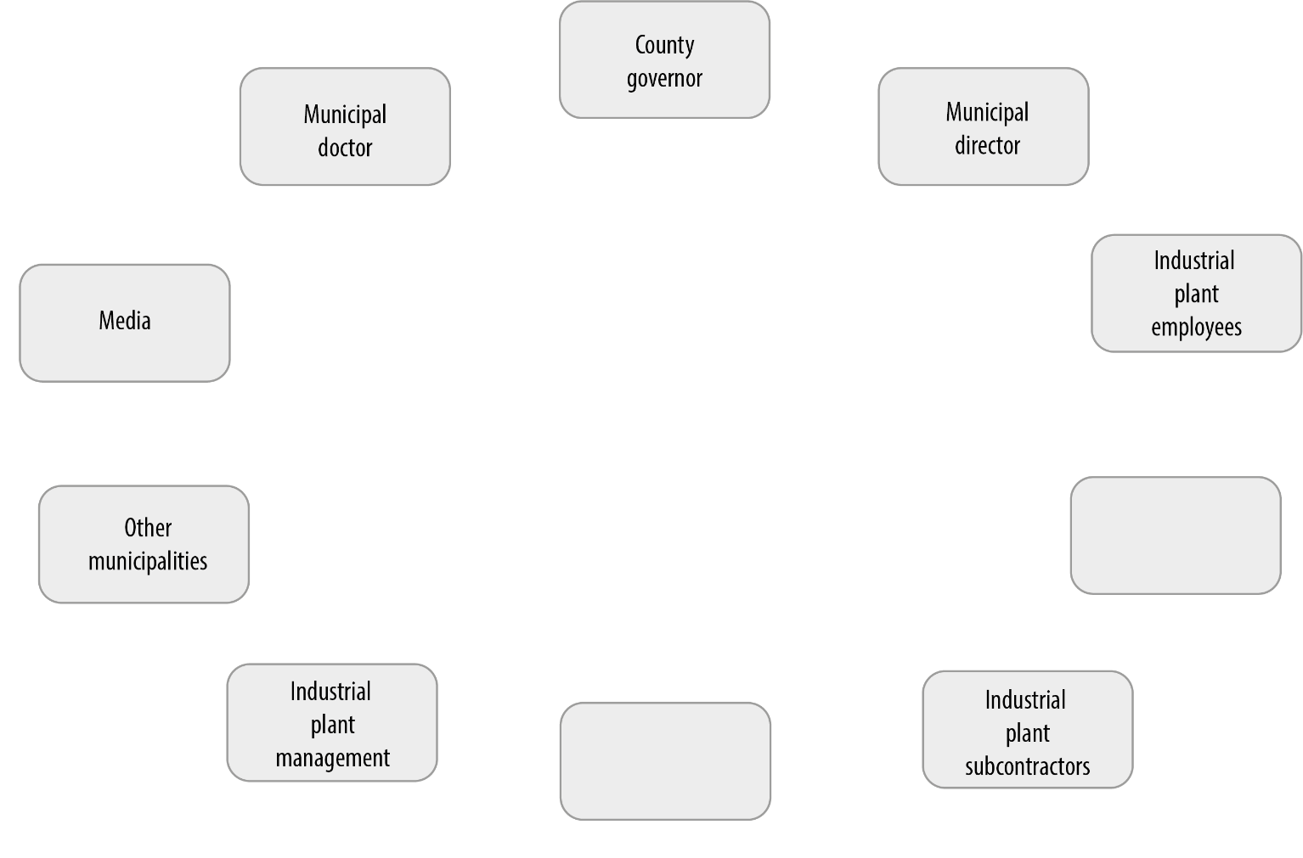

Each actor involved in the outbreak response designates one contact person responsible for communication with other actors. The industrial plant organises a secure “cloud computing” workspace and grants access to representatives of the municipality, in order to share confidential information on employees.
The municipal doctor and the employer decide to have daily meetings to review the status of the outbreak, discuss control measures, and exchange other key information. The employer decides to have daily meetings with subcontractors to review the status of the outbreak and to improve sharing of information with all employees. Finally, the county governor decides to call for weekly meetings of all neighbouring municipalities to review the status of the outbreak and to improve sharing of information and resources. The outbreak investigation team sketches an information flowchart aimed to help information exchanges.
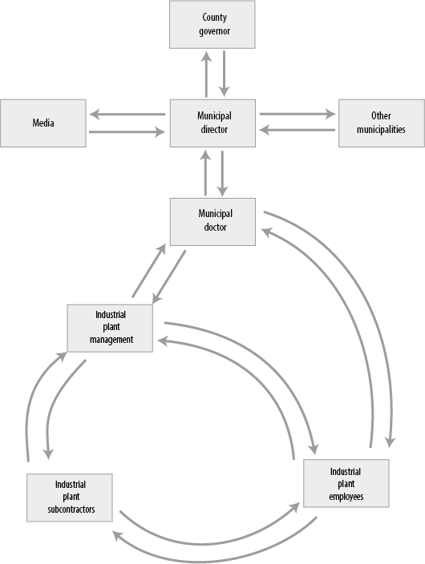
Question:
- Based on the previous discussions, add the contents of the communication for each arrow to the flowchart above.
PART III. OUTBREAK RESPONSE
(estimated time: 60 minutes)

The outbreak investigation team discusses whether this COVID-19 outbreak involves the whole community or whether it is limited to the industrial plant. They review the information they received from key actors and they find out that:
- Of the 1,350 municipality inhabitants, 3 persons were registered as cases
- Of the 455 plant employees, 75 persons were registered as cases

Question:
- What factors can explain the different case numbers between the municipality inhabitants and the foreign temporary workers?

Around the world, foreign workers, especially if they travel to a country for temporary or seasonal work, tend to stick together. These groups are often vulnerable in terms of access to health care and information. This could be due to factors including language differences, shared cultural background which differs from the host population, housing far from town provided by employer, or other barriers or preferences.
In this case, the foreign temporary workers spend most of their time at the plant and the barracks that are set up on the premises. They spend evenings cooking together, playing cards and chatting. Their interaction with other plant employees and municipality inhabitants is limited. You could almost imagine that they are living in a social bubble isolated from the surrounding community. This limited mobility may have minimized the transmission of COVID-19 from the plant employees to the permanent residents (see figure 2).

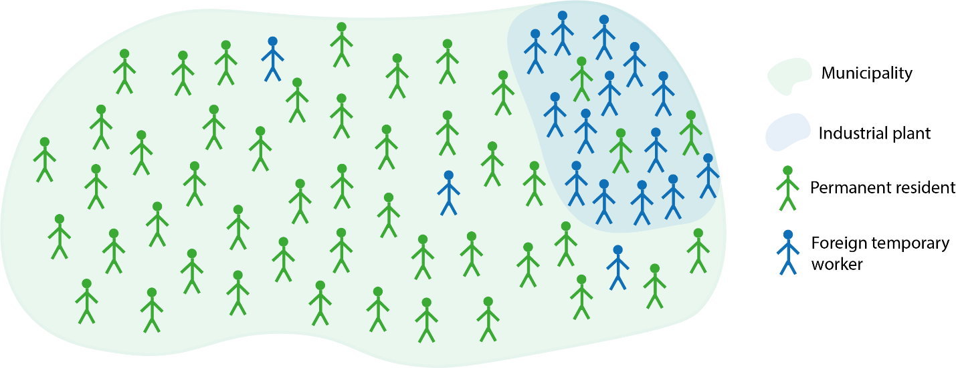
Figure 2. Illustration of the isolated social bubble of foreign temporary workers

Question:
- Where would you implement control measures?

The outbreak investigation team decides that the investigation and control measures should be focused on the industry plant employees. At the same time, the municipal doctor should carefully monitor the situation in the community.
In order to get a better overview of the current outbreak, and to be able to monitor how the outbreak progresses, the outbreak investigation team decides to describe the reported COVID-19 cases by person, place and time. They use the information on cases collected by the municipal contact tracing team.
The municipality doctor had over a longer time requested the municipal director for a contact tracing team. This was not organised before the start of this outbreak and it was set up in hurry when the first cases were diagnosed. A team from a neighbouring municipality organised a short training for the new contact tracing team. The municipal doctor decides to use the online disease tracing software ReMin. This software is a simple and easy to use. Based on the positive test results received from the laboratory, the contract tracing team calls persons with a positive test and records a list of their close contacts. The following challenges are identified regarding capturing of information on cases and their contacts:
- Lack of experience and work routines in disease outbreaks (persons tasked with contact tracing were delegated from other tasks in the municipality and they are not health professionals).
- Key information for cases (for example symptoms, date of symptom onset, date of testing, etc) is not captured systematically.
- Ineffective communication between the contact tracing team, municipal doctor and cases, due to language barriers (many of the cases and contacts did not speak English or Norwegian).
- Discontinuation of contact tracing because of the assumption that everyone in the industry plant is a close contact of one of the cases.
As agreed during the first meeting organised by the county governor, neighbouring municipalities help the municipal doctor to recruit health workers speaking the most common foreign languages of the affected population. The health workers start calling all plant employees who are currently in isolation or quarantine, to check their health status and inform them about the recommended precautions.
ReMin does not support data manipulations, data export nor data analysis. The FHI team therefore advises the municipal doctor to prepare a line list of cases using MS Excel, in order to monitor the outbreak. A line list is a simple table where a row represents a confirmed case. Columns contain important variable that allow the description of cases by time, place and person, using Excel or another statistical software.
Note: before preparing the line list, the epidemiologists should always elaborate a “case definition”. The case definition includes information on person, place and time and allows separating the cases belonging to a given outbreak (in this case: employees of the industrial plant present at work from mid-September until mid-October) from unrelated cases.
Question:
- What information would you want to collect in the line list on each positive case?

Based on the information obtained from employees of the industry plant that tested positive for COVID-19 and from the information captured in ReMin, the outbreak investigation team prepared a line list.
Table 1. Line list of confirmed COVID-19 cases
ID | Sex | Age | Nationality | Residence | Symptoms | Date of onset | Date of sample
1 | Male | 44 | Country A | Barrack 1 |  |  | 18. aug
2 | Male | 49 | Country A | Barrack 1 | Yes | 08. aug | 7. aug
3 | Male | 28 | Country A |  |  |  | 29. aug
4 | Male | 65 | Country A | Barrack 2 |  |  | 22. aug
5 | Male | 55 | Country D | Resident | No |  | 12. aug
6 | Male | 36 | Country A | Barrack 2 |  |  | 29. aug
7 | Male | 31 | Country A | Barrack 1 | Yes |  | 29. aug
8 | Male | 20 | Country A |  | No |  | 21. aug
9 | Male | 44 | Country A | Barrack 2 | Yes |  | 26. aug
10 | Male | 58 | Country A | Rented house 1 | No |  | 26. aug
11 | Male | 44 | Country A | Barrack 2 |  |  | 21. aug
12 | Male | 31 | Country A |  | No |  | 21. aug
13 | Male | 61 | Country A | Barrack 1 | No |  | 21. aug
14 | Male | 42 | Country A | Rented house 2 |  |  | 23. aug
15 | Male | 54 | Country A | Barrack 2 |  |  | 26. aug
16 | Male | 58 | Country A | Barrack 1 | Yes |  | 23. aug
17 | Male | 45 | Country A | Barrack 2 |  |  | 20. aug
18 | Male | 42 | Norwegian | Resident | Yes |  | 20. aug
19 | Male | 47 | Country A | Barrack 2 |  |  | 20. aug
20 | Male | 56 | Norwegian | Rented house 3 | Yes | 22. aug | 22. aug
21 | Male | 65 | Country B | Barrack 1 |  |  | 22. aug
22 | Male | 42 | Country A | Barrack 1 |  |  | 22. aug
23 | Male | 42 | Country A | Barrack 2 |  |  | 22. aug
24 | Male | 43 | Country B | Barrack 3 | Yes |  | 22. aug
25 | Male | 47 | Country A | Barrack 2 |  |  | 29. aug
26 | Male | 53 | Norwegian | Resident | Yes |  | 22. aug
27 | Male | 25 | Country A | Barrack 4 |  |  | 22. aug
28 | Male | 38 | Country A | Rented house 1 |  |  | 29. aug
29 | Male | 45 | Country A | Barrack 4 |  |  | 22. aug
30 | Male | 47 | Country B | Barrack 2 | No |  | 22. aug
31 | Male | 37 | Country A | Barrack 1 | No |  | 22. aug
32 | Male | 41 | Country A |  | No |  | 22. aug
33 | Male | 48 | Country A | Barrack 2 | Yes |  | 22. aug
34 | Male | 49 | Country A | Barrack 5 | Yes |  | 22. aug
35 | Male | 37 | Country B | Barrack 2 | No |  | 22. aug
36 | Male | 57 | Country A | Barrack 2 | Yes |  | 23. aug
37 | Male | 23 | Country A | Barrack 2 | No |  | 23. aug
38 | Male | 54 | Country A | Barrack 2 | No |  | 23. aug

ID | Sex | Age | Nationality | Residence | Symptoms | Date of onset | Date of sample
39 | Male | 45 | Country A | Barrack 3 |  |  | 23. aug
40 | Male | 44 | Country A | Rented house 1 |  |  | 23. aug
41 | Male | 55 | Country A | Barrack 2 | Yes |  | 23. aug
42 | Male | 48 | Country A | Barrack 2 |  |  | 23. aug
43 | Male | 63 | Country A | Barrack 3 | No |  | 23. aug
44 | Male | 37 | Country A | Barrack 2 | Yes | 23. aug | 23. aug
45 | Male | 40 | Country A |  | Yes | 28. aug | 23. aug
46 | Male | 46 | Country A | Barrack 2 | Yes |  | 23. aug
47 | Male | 54 | Country A | Barrack 3 | Yes |  | 25. aug
48 | Male | 34 | Country B | Barrack 1 |  |  | 23. aug
49 | Male | 45 | Country A | Rented house 1 | No |  | 23. aug
50 | Male | 46 | Country A | Barrack 3 | Yes |  | 23. aug
51 | Male | 51 | Country A | Barrack 2 |  |  | 23. aug
52 | Male | 44 | Country A |  | No |  | 23. aug
53 | Male | 33 | Country A | Barrack 3 |  |  | 23. aug
54 | Male | 35 | Country B | Barrack 2 | No |  | 23. aug
55 | Male | 61 | Country A | Rented house 1 |  |  | 29. aug
56 | Male | 23 | Country A | Rented house 1 |  |  | 29. aug
57 | Male | 38 | Country A | Barrack 1 |  |  | 29. aug
58 | Male | 52 | Country A | Barrack 2 |  |  | 29. aug
59 | Male | 36 | Country A |  |  |  | 29. aug
60 | Male | 51 | Country A | Rented house 1 | Yes | 28. aug | 25. aug
61 | Male | 47 | Country B | Barrack 3 | No |  | 25. aug
62 | Male | 53 | Country B | Barrack 2 | No |  | 25. aug
63 | Male | 41 | Country B | Barrack 2 | No |  | 25. aug
64 | Male | 44 | Country B | Barrack 2 | No |  | 25. aug
65 | Male | 45 | Country B | Rented house 3 | No |  | 25. aug
66 | Male | 42 | Country A | Barrack 2 | No |  | 25. aug
67 | Male | 63 | Country A | Rented house 1 |  |  | 25. aug
68 | Male | 34 | Country B | Barrack 2 |  |  | 25. aug
69 | Male | 62 | Country C | Barrack 4 | No |  | 25. aug
70 | Male | 41 | Country A |  | No |  | 25. aug
71 | Male | 48 | Country A | Barrack 2 | No |  | 24. aug
72 | Male | 45 | Country A | Barrack 1 | No |  | 23. aug
73 | Male | 60 | Country A | Barrack 2 | No |  | 23. aug
74 | Male | 52 | Country A |  | No |  | 23. aug
75 | Male | 59 | Country A | Barrack 4 | No |  | 23. aug

Questions:
- How can you summarise the information from the above line list of cases?

- Complete and interpret the following tables, using data from the line list:

Age (years) | Number of cases | % by category
18-29
30-39
40-49
50-59
>60
TOTAL

Nationality | Number of cases | % by category
Norwegian
Country A
Country B
Other country
TOTAL

Residence | Number of cases | % by category
Barrack 1
Barrack 2
Barrack 3
Barrack 4
Barrack 5
Rented house 1
Rented house 2
Rented house 3
Permanent resident
Missing information
TOTAL

The outbreak investigation team summarizes the available data and prepares the following illustrations. The municipal spokesperson suggests that this kind of information could be included in the daily situation report.

Figure 3. Number of cases among plant employees by date of specimen collection.
Note that using date of symptom onset would give a more accurate picture of the development of the outbreak. The date of specimen collection reflects testing practices. For asymptomatic cases, however, the date of specimen collection is the only available date that can be used as a “proxy date” to follow outbreak development in time.
Table 2. Number of cases among plant employees by age group.
Age (years) | Number of cases | % by category
18-29 | 5 | 7 %
30-39 | 13 | 17 %
40-49 | 33 | 44 %
50-59 | 16 | 21 %
>60 | 8 | 11 %
TOTAL | 75 | 100 %

Table 3. Number of cases among plant employees by nationality.
Nationality | Number of cases | % by category
Norwegian | 3 | 4 %
Country A | 58 | 77 %
Country B | 12 | 16 %
Other country | 2 | 3 %
TOTAL | 75 | 100 %
Table 4. Number of cases among plant employees by place of residence before the outbreak.
Residence | Number of cases | % by category
Barrack 1 | 11 | 15 %
Barrack 2 | 29 | 39 %
Barrack 3 | 7 | 9 %
Barrack 4 | 4 | 5 %
Barrack 5 | 1 | 1 %
Rented house 1 | 8 | 11 %
Rented house 2 | 1 | 1 %
Rented house 3 | 2 | 3 %
Permanent resident | 3 | 4 %
Missing information | 9 | 12 %
TOTAL | 75 | 100 %

The outbreak investigation team discusses the characteristics of reported cases so far:
- All reported cases are male.
- The most affected age group is 40-49 years.
- Most cases are reported among foreign nationals born in country A, fewer cases are reported among foreign workers from country B and sporadic cases among other nationalities.
- Most cases live in three of the five barracks, but there are also cases among employees living in rented houses in the neighbouring villages.
The outbreak team agrees that the information available does not allow for an interpretation of the disease risk. In order to measure the disease risk, information is required on people who became ill and on those who did not. The probability of being infected can then be calculated. In outbreak settings such a measure of probability is called the “attack rate”. This attack rate can be used to compare whether the risk of falling ill differs between groups. For example, you could calculate and compare attack rates between employees of different nationalities, or between employees of different age.

Question:
- In addition to the line list, what information does the municipal doctor need to calculate the attack rates? Propose a layout of a table and draw it on the side of one of the above tables.

The municipal doctor wants to know if the COVID-19 risk differs by age group. If she can identify which age groups are most at risk for COVID-19 infection, the control measures can be focused on the most affected age groups. She adds three new columns to her distribution of cases by age:
Table 5. Layout needed to calculate attack rate per age group
Age (years) | All employees | Not ill | Ill (cases) | Risk (attack rate)
18-29 |  |  | 6
30-39 |  |  | 15
40-49 |  |  | 39
50-59 |  |  | 17
>60 |  |  | 8
TOTAL |  |  | 85

In order to get an idea of the number of employees who are not ill, and to allow for the calculation of the attack rates per group, the municipal doctor asks the industrial plant management to prepare a table with the number of employees grouped by sex, age, residence and nationality, and to identify to which groups the reported COVID-19 cases belong. Unfortunately, it is difficult for the employer to prioritize getting such an overview table as it must focus on crisis communication and the management of testing a large group of employees.
Considering that it is difficult to calculate attack rates for specific groups, the outbreak investigation team starts to review the control and containment measures, to see how these could be strengthened. Some of these control measures were already in place prior to the arrival of the FHI delegation. When reviewing the applied control measures, the outbreak team finds that in the early stages of the outbreak the employer did not consult with the municipal doctor the implementation of some of the control measures. As a result, control measures implemented by the employer were not aligned with the national guidance. For example, the employer required confirmed cases to remain in isolation until they had a negative test result. However, the national guidelines stated that isolation ends 10 days after the date of positive test for asymptomatic cases, and 10 days after symptom onset for symptomatic cases if the patient is not febrile. Therefore, many employees who were kept in isolation longer than required and were unable to return to their home countries. The employees became stressed because they did not understand what was happening and could not obtain any information on their status and when they could return home.

Question:
- What barriers might you encounter when implementing control measures in a similar setting?

- How could you mitigate against them? For this discussion you can use the table below. The first row was filled in using the example from the actual outbreak.

Control measure | Potential challenge | Potential mitigation strategy
Quarantine or isolation of employees | Lack of adherence | Employer to facilitate isolation, ensuring access to food and bathroom facilities and continued payment of salary

PART IV. HOW CAN THE MUNICIPALITY PREPARE BETTER FOR THE NEXT OUTBREAK?
(estimated time: 45 minutes)

While containment measures are being implemented and the municipal doctor continues to monitor the COVID-19 outbreak, the municipal leadership and the plant management reflect on how they can better prepare for the next outbreak. They expect new outbreaks to occur in the future. Since closing such industry plants and other workplaces which employ temporary foreign workers would affect the local economy and many small businesses in the area, the plant will continue to function by employing temporary foreign workers who come to Norway from abroad for short-term rotations. The actors evaluate the outbreak investigation, aiming to identify ‘lessons learned’ that can help control future outbreaks in the plant and municipality. These can also be applied to other settings, such as other municipalities with substantial foreign temporary workforce.

Questions:
- What do you think are the ‘lessons learned’ in terms of preparedness and communication?

- How could key actors of outbreak response in this municipality, prepare themselves for future outbreaks?

The outbreak investigation team believes that if the municipality prepares in advance and develops a working cooperation with the employer, it can react more rapidly and effectively to limit disease spread in future outbreaks. Employees of the plant are vulnerable. Each time a new group of temporary foreign workers comes to Norway, it can potentially bring new infections. And the virus can easily spread when so many people live and work so close together.
Therefore, the outbreak investigation team recommends that the municipality updates the existing crisis preparedness plan. One of the main aims of a preparedness plan is to establish collaborative working routines and communication channels with all key actors. Experiences from this outbreak are invaluable for the revision of the preparedness plan. A new plan based on these experiences will enable all key actors to quickly activate the outbreak response, take up their assigned roles, responsibilities and engage in the clearly defined communication channels. This will likely save precious time and limit misunderstandings. Planning of roles, responsibilities and tasks should be set up in collaboration between the municipal doctor, public health services, plant management, neighbouring municipalities and the county governor. Established, tested communication channels can help with:
- Transparent and rapid sharing of information on testing strategy and results.
- Transparent and rapid sharing of information about the situation with inhabitants in the community and the media.
- Good overview of current status of persons in isolation and quarantine.
- Rapid dissemination of eventual changes in TISK rules among partners.
- Rapid dissemination of relevant materials in foreign languages, as soon as they become available.
- Effective sharing of resources between municipalities, in terms of competent personnel speaking a specific language.
- Preparation in advance for new temporary foreign worker groups coming from abroad.

Question:
- How can different key actors better coordinate control measures in case of a future outbreak?

To prepare better for future outbreaks, the outbreak investigation team proposes to strengthen coordination of stakeholders’ activities by developing Standard Operating Procedures for daily and weekly meetings, template situation reports, template line lists, etc. These can be included in the municipal preparedness plan and operationalised rapidly when the outbreak is declared. In addition, the outbreak investigation team recognises the importance of epidemiological data that should guide the implementation of control measures. For example, if cases first occur only in one barrack among employees working in the same team, rapid intervention can limit the spread to other groups of workers. Therefore, it is important that the employer keeps up-to-date and complete register of all employees. They need to provide the required information at short notice.
It is also important for key actors to be familiar with public health guidance prior to the occurrence of the outbreak and to ensure these are followed, especially in times of crisis. Members of the outbreak investigation team conclude that it is too late to develop communication channels and set up employee registers when the outbreak occurs, because everyone is focused on “extinguishing fires”, and that therefore these preparations should be in place prior to the onset of an outbreak.

Question:
- How can the municipality prepare to communicate to the municipality inhabitants and other key actors during a crisis, to decrease the social distress and countermeasure potential stigmatisation of foreign workers?

During a crisis, communication between authorities and the community faces different challenges than during “peace time”. If communication is not handled appropriately, residents can feel concern, discomfort, fear, and even outrage. In such situation, it is easy to blame others like foreign temporary workers. In this outbreak, the municipal director was facing accusations from permanent residents, media and other municipalities, blaming the foreign temporary workers for spreading infections and endangering the permanent residents.
The outbreak investigation team suggested to develop a communication plan to be implemented in case of a crisis, including:
- Planning for early, frequent and open communication from municipal authorities about what is known and what is not known about the situation.
- Planning for communication directed both to the permanent residents and to foreign temporary workers, adjusting the messages and language, if necessary.
- Identify a spokesperson among foreign workers (and/or other vulnerable groups) and work together on effective communication between the community and foreign workers group.
Proactive communication can help in assuring people’s trust and make sure they will comply with recommended control measures, if needed.
One way to prevent stigmatisation of foreign temporary workers might be to “give them a voice”, by collaborating and seek to establish a spokesperson who could talk on their behalf. This person could inform the actors involved in the future outbreak response about the situation in his/her group. The spokesperson could also communicate to the local community on behalf of his/her group through the media or through the website/social media of the municipal authorities. If the community is well informed, it will possibly be less concerned and less likely to stigmatize the foreigners.

As we have seen in this case study, it is difficult to set up communication lines and define roles and responsibilities when an outbreak has already started. Most likely the pressure of the media and neighbouring municipalities will be high. Additionally, the urgency of the outbreak can lead to disorganized and confusing lines of communication. Therefore, agreeing on communication channels as a part of preparedness planning is crucial as described above. One way of doing this can be to draw a communication flow. An example of a communication flow that was made by the key actors in this case study can be found below.
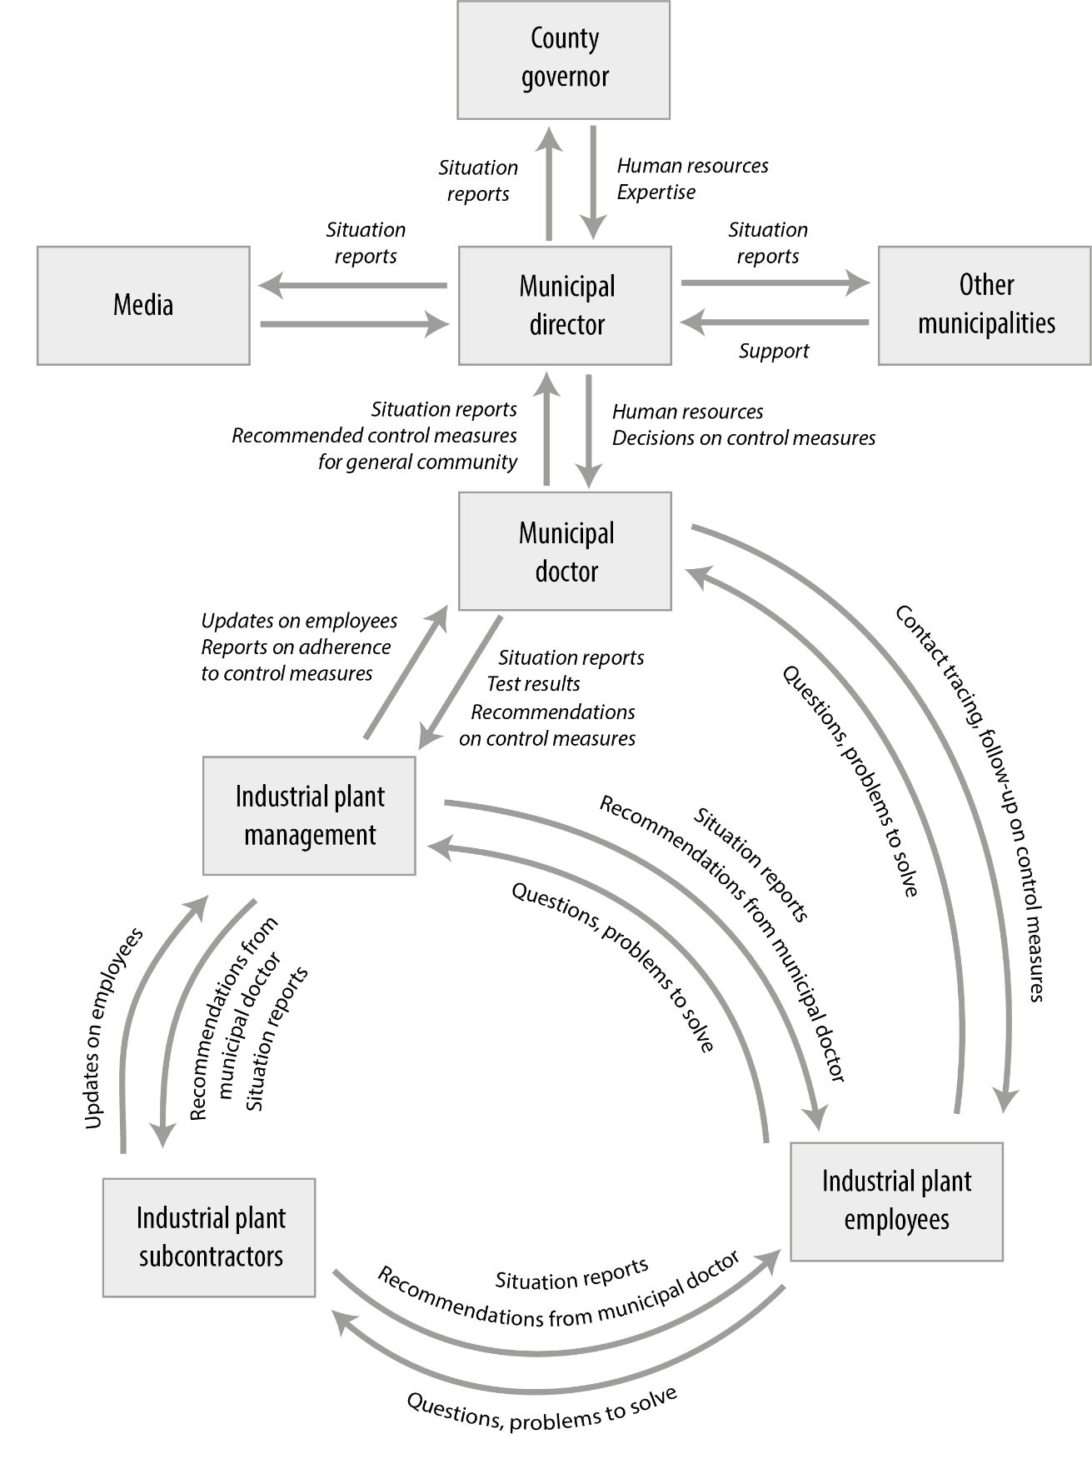
Figure 4. Information flowchart for crisis communication
Two weeks after the outbreak, members of the outbreak investigation team receive an email from the municipal doctor who has collaborated with the industrial plant management to track down the number of employees. She also sends the information on the employees' distribution by category as requested. This information allows you to fill out the below tables and calculate the attack rates. Remember that attack rates are expressed as a percentage (100*number of cases/employees).
Question:
- Complete the below tables.
- How should these tables be interpreted?
- Why is it important to have these tables?
Age (years) | Employees | Number of cases | Attack rate (%)
18-30 | 46
30-39 | 88
40-49 | 149
50-59 | 98
>60 | 33
Missing | 41
TOTAL | 455

Nationality | Employees | Number of cases | Attack rate (%)
Norwegian | 109
Country A | 269
Country B | 37
Other country | 40
TOTAL | 455

Residence | Employees | Number of cases | Attack rate (%)
Barrack 1 | 45
Barrack 2 | 54
Barrack 3 | 52
Barrack 4 | 48
Barrack 5 | 62
Rented house 1 | 10
Rented house 2 | 12
Rented house 3 | 10
Rented house 4 | 12
Rented house 5 | 8
Rented house 6 | 16
Permenent | 142
TOTAL | 455

Table 6. Attack rates among plant employees by age.
Age (years) | Employees | Number of cases | Attack rate (%)
18-29 | 46 | 5 | 11 %
30-39 | 88 | 13 | 15 %
40-49 | 149 | 33 | 22 %
50-59 | 98 | 16 | 16 %
>60 | 33 | 8 | 24 %
Missing | 41 | 0 | 0 %
TOTAL | 455 | 75 | 16 %

Table 7. Attack rates among plant employees by nationality.
Nationality | Employees | Number of cases | Attack rate (%)
Norwegian | 109 | 3 | 3 %
Country A | 269 | 58 | 22 %
Country B | 37 | 12 | 32 %
Other country | 40 | 2 | 5 %
TOTAL | 455 | 75 | 16 %

Table 8. Attack rates among plant employees by place of residence before the outbreak.
Residence | Employees | Number of cases | Attack rate (%)
Barrack 1 | 45 | 11 | 24 %
Barrack 2 | 54 | 29 | 54 %
Barrack 3 | 52 | 7 | 13 %
Barrack 4 | 48 | 4 | 8 %
Barrack 5 | 62 | 1 | 2 %
Rented house 1 | 10 | 8 | 80 %
Rented house 2 | 12 | 1 | 8 %
Rented house 3 | 10 | 2 | 20 %
Rented house 4 | 12 | 0 | 0 %
Rented house 5 | 8 | 0 | 0 %
Rented house 6 | 16 | 0 | 0 %
Permanent resident | 142 | 3 | 2 %
Missing information | - | 9 | N/A
TOTAL | 455 | 75 | 16 %

By having information on the number of employees and the number of cases for each age group, nationality and (temporary) place of residence, the municipal doctor and outbreak investigation team were able to pinpoint in which age group, nationality and (temporary) place of residence the attack rate of COVID-19 was highest during the outbreak. If they had been able to calculate this during the outbreak, they could have taken tailored and targeted control measures that would potentially have contained the outbreak earlier on.
For example, during the outbreak all the attention was directed to the largest group of foreign workers from Country A, having most of reported cases. This belief that infection spreads only in one group, lead to focusing control measures on this group, which also suffered stigmatization. However, when the number of cases was placed in the context of how numerous groups were (Table 7), the municipal doctor saw that the higher risk was observed in temporary workers from country B. A possible explanation for this would be that there were more interactions within a smaller group that was more integrated and for any reason complied less with recommended control measures. Knowing this at the beginning of the outbreak could help in better directing response and communication. Similarly, knowing more about the age and residence of the affected population, could help in faster and more targeted response.

Question:
- What were the main learning points from this case study, and what is the main message to take home about effective outbreak response?

On the last evening of their stay in this small municipality, the outbreak investigation team debriefed and recorded the main lessons learned from the COVID-19 outbreak in this small municipality:

P : Prepared municipality can react faster and more efficiently
R : Response can start faster if key actors are identified in advance
E : Each actor must have a defined contact person, role and responsibilities
P : Preparedness plan includes mapping vulnerable populations
A : Analysis of risk is possible if data on vulnerable population is ready in advance
R : Response is effective if communication is effective
E : Epidemiological data warrants an evidence-based response

PART V. EPILOGUE
Six weeks after the first outbreak, and four weeks after closing the outbreak investigation, a new COVID-19 outbreak occurred in the same industry plant. The plant has opened again, and new groups of foreign workers came from their home countries to work at the plant. This time all the stakeholders were better prepared and managed to respond faster. This resulted in a smaller outbreak involving approximately 20 cases among quarantined group travelling from abroad. The outbreak did not affect other groups of workers and permanent residents. This shows that the municipality and the employer has developed better routines in terms of isolating and quarantining workers coming from abroad. However, the employer could improve compliance of foreign workers with the quarantine rules. This example shows that preparing for the crisis is a continuous process, where there is always room for improvement. Municipalities should learn from each new crisis how to further improve their preparedness planning. Each new outbreak creates an opportunity to test working routines, accumulate knowledge and increase preparedness. One could say that the more outbreaks a municipality will experience, the better it will be prepared.
Also, at the national level, the infection control measures have been adapted to the epidemiological situation during the COVID-19 pandemic. One example is the introduction of reinforced TISK in the spring of 2021, after the spread of more infectious virus variants. Reinforced TISK means more extensive testing and quarantine, and more emphasis on good implementation of quarantine and isolation.

https://www.fylkesmannen.no/innlandet/helse-omsorg-og-sosialtjenester/smittevern/coronavirus/tisk---nasjonalt-system-for-a-holde-koronatallene-nede/
https://www.fhi.no/nettpub/coronavirus/testing-og-oppfolging-av-smittede/hjemmekarantene-og-hjemmeisolering-i-forbindelse-med-covid-19/?term=&h=1#unntak-fra-karanteneplikten
https://www.ecdc.europa.eu/en/covid-19/latest-evidence/transmission
https://www.ecdc.europa.eu/sites/default/files/documents/COVID-19-in-occupational-settings.pdf
https://www.sciencedirect.com/science/article/pii/S1201971220303325
https://www.helsedirektoratet.no/faglige-rad/pandemiplanlegging
https://www.fhi.no/nettpub/coronavirus/testing-og-oppfolging-av-smittede/forsterket-tisk2/?term=&h=1

